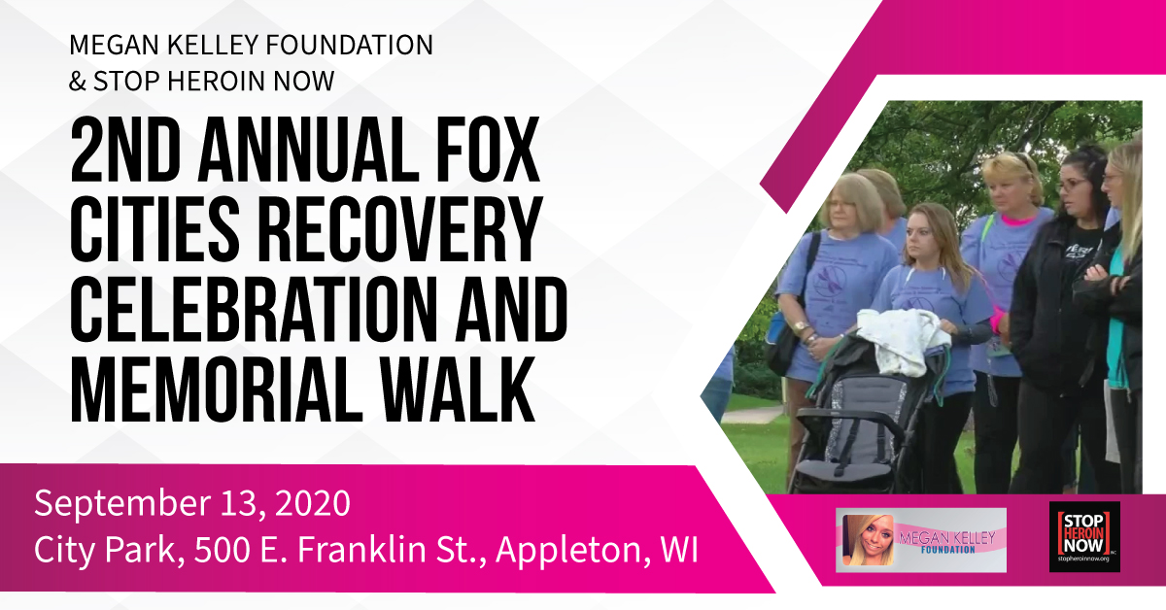
Due to the Covid-19 pandemic, the City of Appleton requested that we offer timeslots to limit the participants to 50 per time slot. Please circle the time slot that works best for you and indicate 1 or 2 for your time preference: ___1:00-2:15 ___2:30-3:45 pm ___4:00-5:15 pm
We will contact you prior to the Walk concerning your time slot. We will make every effort to accommodate your 1st choice. The Walk celebrates those in recovery and allows us to honor those who lost their lives to addiction.

We also need to limit the Fox Cities Lights of Hope event to 50 people. Let us know if you are interested in attending.

Receive a t-shirt and Memorial Sign with your registration fee

Registration fees are:
Adults: $15 17 and under $10 Add $2 for XXL , XXXL

We encourage you to sign up online: https://www.megankelleyfoundation.org/fcrecoveryandmemorialwalk
The service fee of $1.50 is waived until August 28. Beginning on August 29, you may sign up online without a guarantee that you will receive a T-shirt or a Memorial Sign

If you wish to sign up by mail, use the form below for each registrant.

Make check payable to: The Megan Kelley Foundation, Memo: FC Recovery and Memorial Walk
Send to:
The Megan Kelley Foundation, Fox Cities Recovery and Memorial Walk
W728 River Bend Dr
Kaukauna, WI 54130

Name: _______________________________________________________________________________________

Address: ____________________________________________________________________________________
City: ________________________________________________________________________________________

Email: _______________________________________________________________________________________
DOB: ________________________________________________________________________________________
Phone: _______________________________________________________________________________________
T-shirt size: Child: S M L
Adult: S M L XL XXL XXXL

